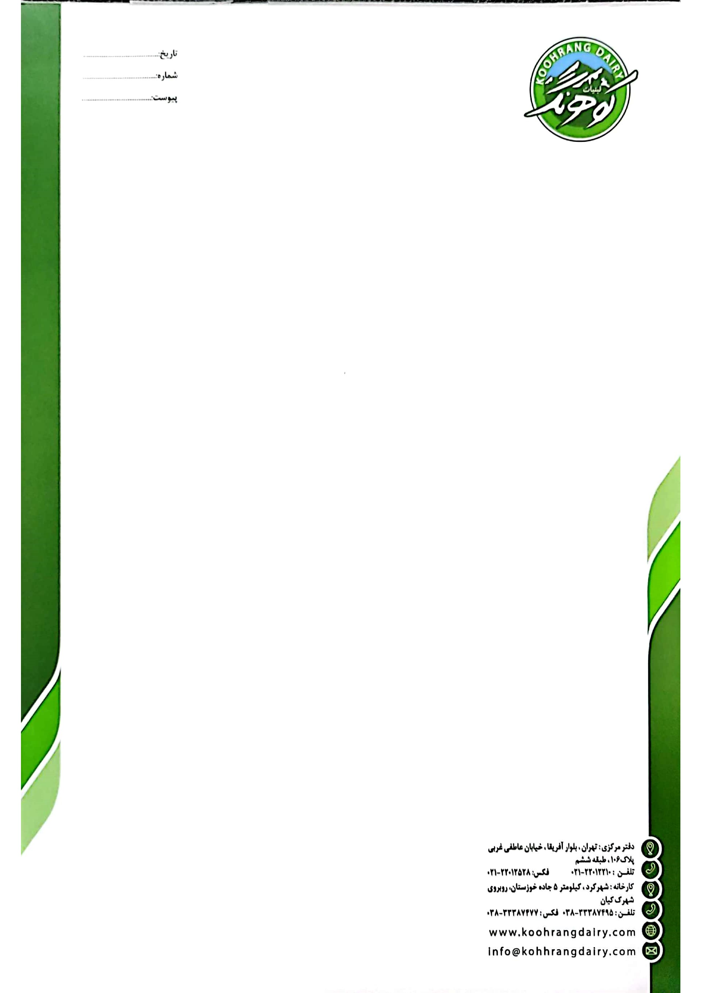
Date: 20.02.2023
To: UNI FOOD General Trading LLC.
Attn.: Mr. Ali Mazinani

Dear Sir/Madam
Thank you for your interest in Koohrang products. The price for a one-liter long-life milk product is as follows:
FOB Bandar Abbas Port: $ 0.52
CFR Jebel Ali Port: $ 0.59
Since the whole packaging process for this product is fully automatic, we cannot change the box format at the beginning. Therefore, initially, this product will be delivered in a 5 x 2 x 1 format (10 pieces). However, we are going to add another packaging line, particularly for your order, to pack the box in 4 x 3 x 1 products, which takes almost 90 days.
We are waiting for your first Purchase Order to issue the Proforma/Invoice and draft of the contract. We look forward to hearing from you soon.

Best Regards,
Koohrang Dairy Company

